Below are a few ideas of how we can layout the room for you.
If your requirements need anything different then please let us know. We are very happy to do bespoke arrangements to suit whatever your event needs.
Please also indicate on your booking form if you require a top table.

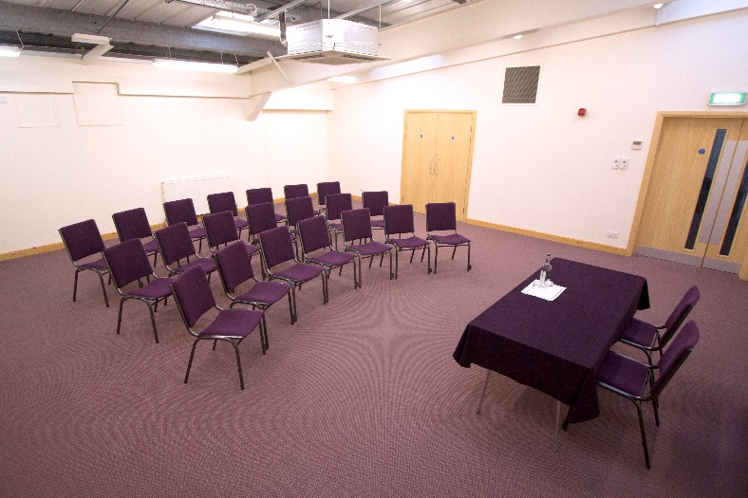
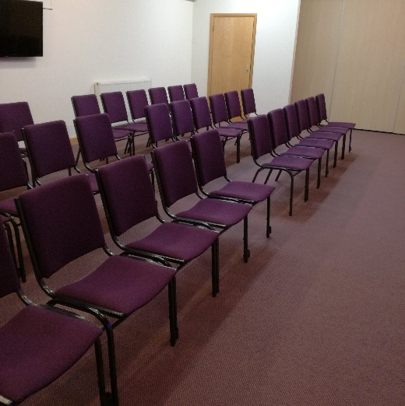

Cinema Style – Straight Rows Theatre Style – Curved Rows

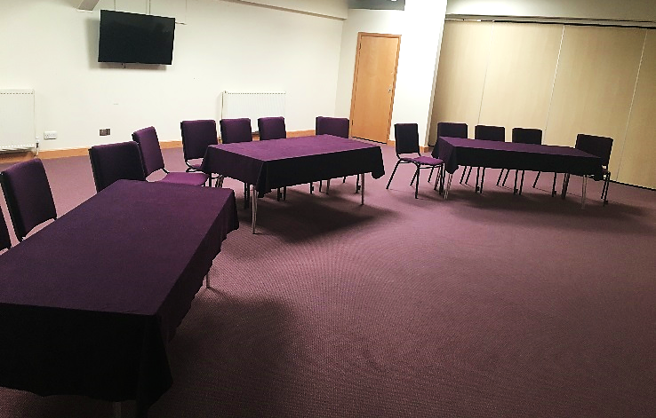
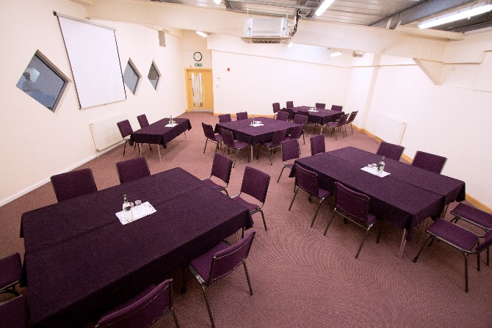

Cabaret Style – Around tables Front facing Cabaret – Around tables facing one direction

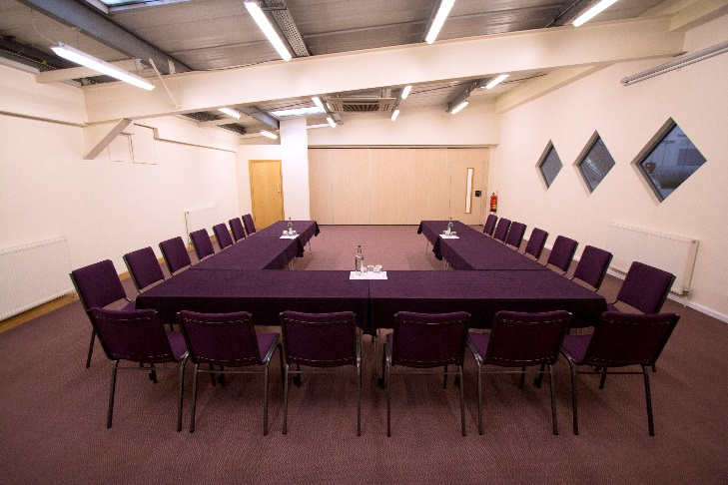
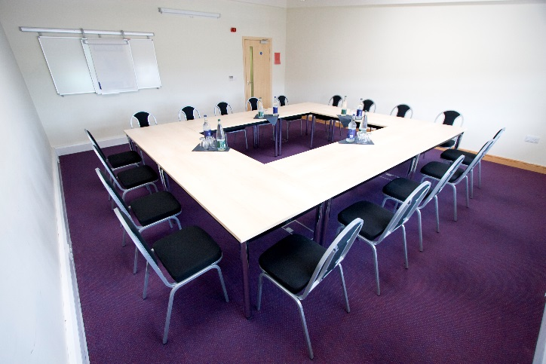

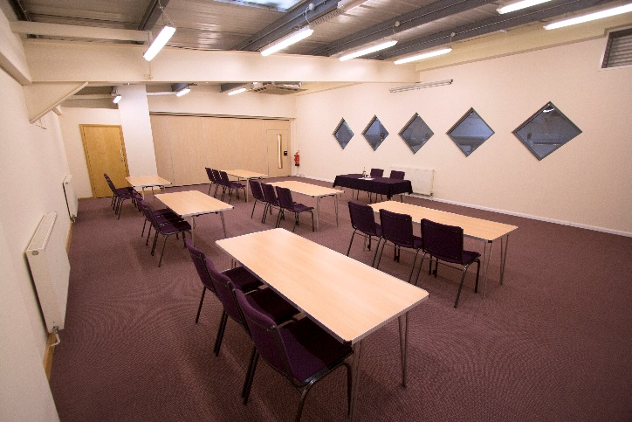
Boardroom – Around a single table Horseshoe – Can be with or without tables
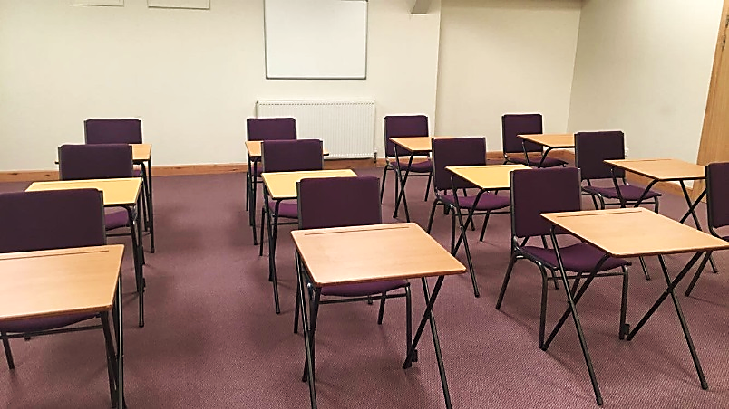

Classroom – Rows of tables Exams – Rows of exam desks

Or give us a call. The possibilities are endless for bespoke layouts to suit your event.
