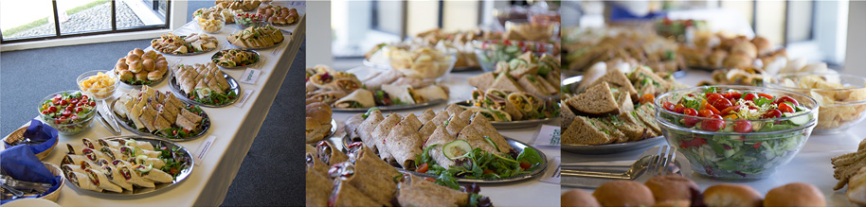

Kings Centre Conference Menus 2017
(Prices exclude VAT)

Menu

Sandwich and Wraps Buffet: £7.25 per person.
A choice from a selection of sandwiches, wraps, mini rolls/bagels:
Smoked salmon, Cream cheese with cracked black pepper, Tuna mayonnaise with cucumber, Tuna mayonnaise with sweetcorn, Ham and wholegrain mustard, Mature cheddar and caramelised red onion chutney, Cream cheese and cucumber, Egg mayonnaise and cress, Egg mayonnaise and watercress, Pancetta, Lettuce and tomato, Brie and cranberry sauce.
Wraps: Coronation chicken, Falafel, humus and carrot, Marinated chargrilled vegetables, New York Deli (pastrami and turkey with sauerkraut and sliced gherkin in mayonnaise), Chicken, bacon and sweetcorn, Falafel savoury in a lightly spiced mayo and yogurt dressing.
Mixed leaf garden salad served with dressings.
or
Vegetable Crudities with individual pots of dips.

Premium crisps.
Selection of cakes (plus some fresh fruit to allow for healthier choices).
Or
Fruit Platters.

Healthier Options Sandwich Buffet: £7.25 per person.

This is similar to the main sandwich buffet but will include more wholemeal and seeded bread varieties. The sandwich/wrap fillings can include any of the above but can also offer the following as an alternative:

Lower fat cheese, Chicken sandwich options such as; Chicken breast, Basil and tomato, Turkey salad, Ham salad, Pesto chicken salad wraps, Mixed bean salad wraps.

Mixed leaf garden salad with low fat dressing and seeds on the side.
Or
Vegetable crudities with lower fat healthy dips.

Cont’d…

Fruit Platters.
Or
A mixture of Fruit Platters and homemade healthier cake options (wholegrains, low sugar/low fat).

Jacket Potato Buffet: £7.25 per person.

Freshly baked jacket potato with a choice of up to 3 fillings:

Coronation chicken, Chicken tikka, Tuna mayonnaise and sweetcorn, Chilli con carne, Grated mature cheese, 3 bean chilli, Baked beans.

Mixed leaf salad with cherry tomatoes, cucumber and sweet peppers served with a dressing.

Home-made fruity red coleslaw.

Fresh fruit platter.

Ploughman’s Buffet: £7.75 per person.

Select up to 3 of the following:

Sliced ham, Turkey, Mature Cheddar, Stilton, Brie or Gala Pie.

Served with a mixed salad, dressing, home-made fruity coleslaw, couscous or potato salad, fresh crusty bread, premium crisps and assorted pickles.

A choice of Fresh fruit platters or cakes (with an additional selection of fresh fruit as a healthy option).

Quiche with a Trio of Salads: £5.75 per person.

A slice of quiche: choose from, Quiche Lorraine, Cheese and onion or Vegetable.

Select 3 salads from:
Mixed leaf garden salad with tomatoes, cucumber, sweet peppers and onion, served with a dressing.
Home-made fruity coleslaw, Potato salad, Couscous salad, Mexican bean salad, Tomato pasta salad.
Others available on request.

Sandwiches and Fruit: £4.50 per person.

A variety of sandwiches equating to 1 round per person. Fillings include:

Tuna mayonnaise, Cheese and pickle, Egg mayonnaise and cress, Ham and wholemeal mustard, Cream cheese and cucumber.

Fresh fruit selection.

Homemade Soup with Crusty Bread & Fruit: £4.50 per person.

Choose from:

Tomato and Basil, Carrot and coriander, Butternut and red pepper, Leek and Potato with seeds or grated cheese topping. Served with a selection of crusty bread.

Add a chunk of cheese for an additional 50p per person.

Selection of fresh fruit.

Morning Menu
Bacon or egg baguette £2.75
Danish Pastry £1.65
Mini Danish Pastry £1.00
Continental breakfast £4.50
(Croissants, rolls, slices of ham and cheese, hard boiled eggs and conserves).

Fresh fruit salad and yogurt £1 extra per head.
Continental biscuits £4.25
(Serving 15 people per plate)

Additional Items
Large cakes per slice £1.95
Small individual cakes 95p
Large cookies 95p
Continental biscuits per plate £4.25
Small Fruit Platter (up to 5 persons) £7.50
Large Fruit Platter (up to 10 persons) £12
Fruit Bowls (up to 10) £6.00

Drinks
Tea/coffee £1.25 per cup
1 litre bottled mineral water £1.95 each
(still/sparkling)
1 litre orange or apple juice £2.25 per jug
Fruit squash 80p per jug

Special dietary requirements can be catered for by pre-order.

