WILLASTON MEMORIAL HALL
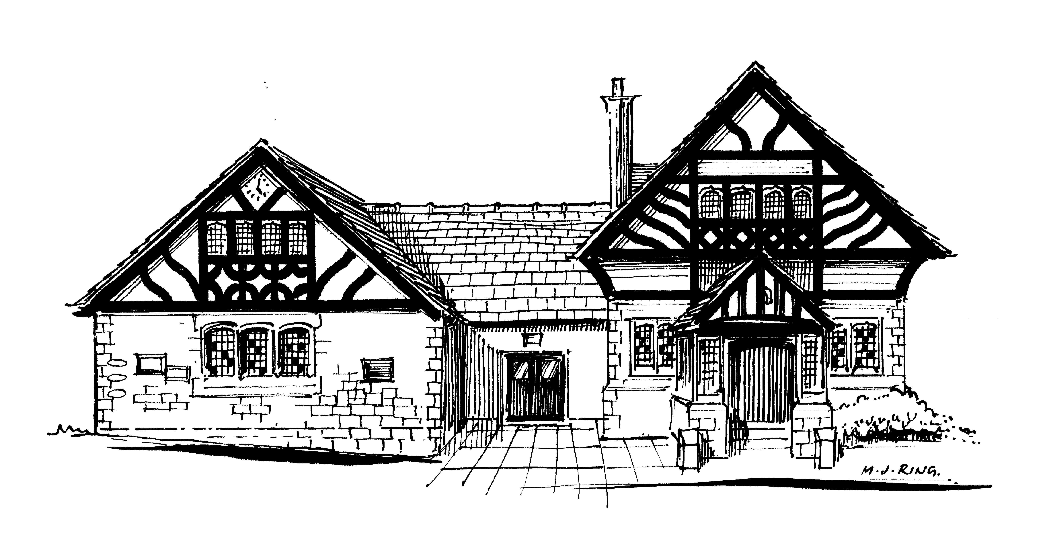
Reg Charity no 520090

The Trustees of Willaston Memorial Hall are looking for volunteers for only a few hours a month.

There are several small jobs which could be carried out by anyone with an hour or two to spare as required and at their own convenience. The Trustees would appreciate volunteers to remove the leaves at the front of the building, weed the flower beds, maintain the gardens at the side and rear, and clean the windows inside and outside.
If you share our interest in maintaining and preserving this valuable asset for the community, then please contact either Colin Jerrett on 0151 923 1240 or Rob King on 0151 353 1101.

